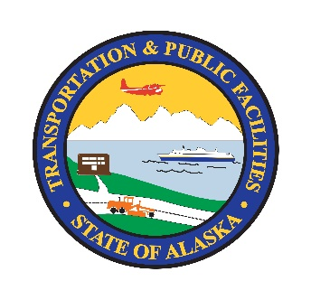 | Department of Transportation and Public Facilities  Environmental Training Plan  Individual Training Plan
Name: Click or tap here to enter text. Position Title: Choose an item.
Region: Choose an item. Section: Click or tap here to enter text.
Time Period Covered: Click or tap to enter a date. to Click or tap to enter a date.
Supervisor: Click or tap here to enter text.

Section I: Past Training
List all training received during the past three calendar years. Add rows, as needed.
Course Name | Institution | Date(s) | Number of Hours

Section II: Career Goals
Describe next logical objective in career goals.
Click or tap here to enter text.
Describe long range goals of employee.
Click or tap here to enter text.

Section III: Requested or Planned Training
Section to be completed with supervisor. Rank in order of priority. Add rows, as needed.
Type | Skills Needed | Course Name (If Available) | Estimated Cost
Please refer to the following in the 2022 Environmental Training Plan for training required for DOT&PF environmental staff: Table 2, Table 3, Appendix B, Appendix C, and Appendix D.

Click or tap to enter a date.
Employee Signature Date
Click or tap to enter a date.
Supervisor Signature Date

List one of the following three types: M (Mandatory), SE (Skills Enhancement), or D (Developmental).

